**MODUL 9 PEMROGRAMAN BERORIENTASI OBJEK**

**GRAPHICAL USER INTERFACE BAGIAN 2**

1. **Output**

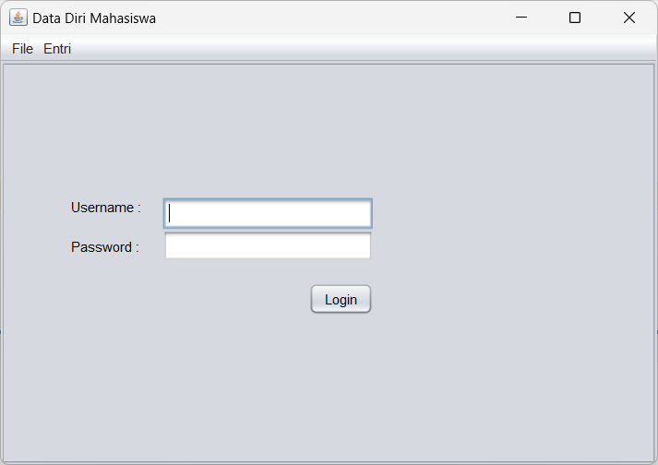 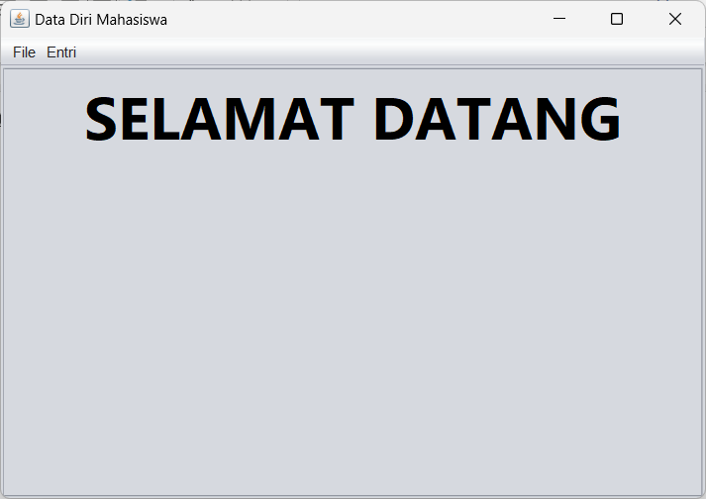

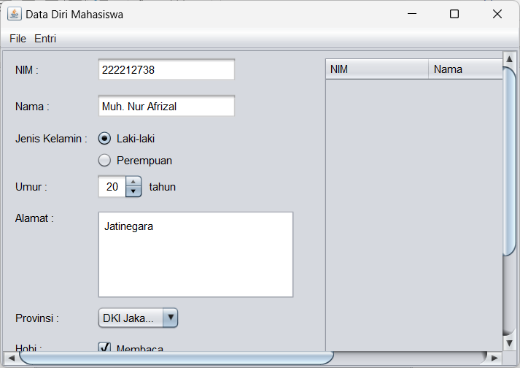 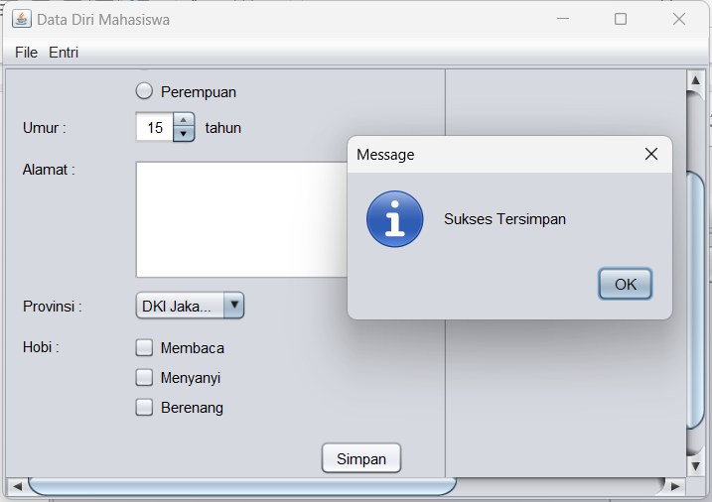

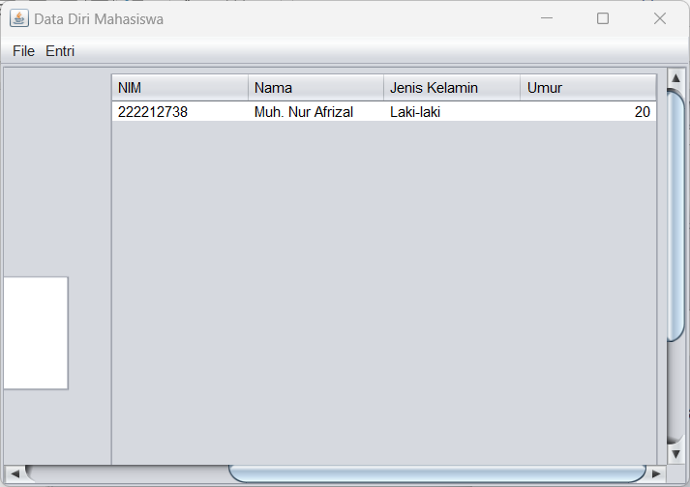

1. **Source Code**

Semua source code tersedia di: <https://github.com/afrzl/Pemrograman-Berorientasi-Objek/blob/d6313155ff07be17bfc11633124c2d400de65810/Week%209/Praktikum/Latihan%20GUI>

1. MainFrame.java

*/\**

*\* Click nbfs://nbhost/SystemFileSystem/Templates/Licenses/license-default.txt to change this license*

*\* Click nbfs://nbhost/SystemFileSystem/Templates/GUIForms/JFrame.java to edit this template*

*\*/*

package latihan.gui;

*/\*\**

*\**

*\* @author muham*

*\*/*

public class MainFrame extends javax.swing.JFrame {

*/\*\**

*\* Creates new form MainFrame*

*\*/*

    public **MainFrame**() {

**initComponents**();

        contentScrollPane.**setViewportView**(new **LoginPanel**(contentScrollPane));

    }

*/\*\**

*\* This method is called from within the constructor to initialize the form.*

*\* WARNING: Do NOT modify this code. The content of this method is always*

*\* regenerated by the Form Editor.*

*\*/*

    @SuppressWarnings("unchecked")

*// <editor-fold defaultstate="collapsed" desc="Generated Code">*

    private void **initComponents**() {

        contentScrollPane = new javax.swing.**JScrollPane**();

        jMenuBar1 = new javax.swing.**JMenuBar**();

        jMenu1 = new javax.swing.**JMenu**();

        homeMenuItem = new javax.swing.**JMenuItem**();

        jMenu2 = new javax.swing.**JMenu**();

        mahasiswaMenuItem = new javax.swing.**JMenuItem**();

**setDefaultCloseOperation**(javax.swing.WindowConstants.EXIT_ON_CLOSE);

**setTitle**("Data Diri Mahasiswa");

        jMenu1.**setText**("File");

        homeMenuItem.**setText**("Home");

        homeMenuItem.**addActionListener**(new java.awt.event.**ActionListener**() {

            public void **actionPerformed**(java.awt.event.ActionEvent evt) {

**homeMenuItemActionPerformed**(evt);

            }

        });

        jMenu1.**add**(homeMenuItem);

        jMenuBar1.**add**(jMenu1);

        jMenu2.**setText**("Entri");

        mahasiswaMenuItem.**setText**("Mahasiswa");

        mahasiswaMenuItem.**addActionListener**(new java.awt.event.**ActionListener**() {

            public void **actionPerformed**(java.awt.event.ActionEvent evt) {

**mahasiswaMenuItemActionPerformed**(evt);

            }

        });

        jMenu2.**add**(mahasiswaMenuItem);

        jMenuBar1.**add**(jMenu2);

**setJMenuBar**(jMenuBar1);

        javax.swing.GroupLayout layout = new javax.swing.**GroupLayout**(**getContentPane**());

**getContentPane**().**setLayout**(layout);

        layout.**setHorizontalGroup**(

            layout.**createParallelGroup**(javax.swing.GroupLayout.Alignment.LEADING)

            .**addComponent**(contentScrollPane, javax.swing.GroupLayout.DEFAULT_SIZE, 569, Short.MAX_VALUE)

        );

        layout.**setVerticalGroup**(

            layout.**createParallelGroup**(javax.swing.GroupLayout.Alignment.LEADING)

            .**addComponent**(contentScrollPane, javax.swing.GroupLayout.DEFAULT_SIZE, 350, Short.MAX_VALUE)

        );

**pack**();

    }*// </editor-fold>*

    private void **homeMenuItemActionPerformed**(java.awt.event.ActionEvent *evt*) {

*// TODO add your handling code here:*

        contentScrollPane.**setViewportView**(new **HomePanel**());

    }

    private void **mahasiswaMenuItemActionPerformed**(java.awt.event.ActionEvent *evt*) {

*// TODO add your handling code here:*

        contentScrollPane.**setViewportView**(new **EntryPanel**());

    }

*/\*\**

*\* @param args the command line arguments*

*\*/*

    public static void **main**(String *args*[]) {

*/* Set the Nimbus look and feel */*

*//<editor-fold defaultstate="collapsed" desc=" Look and feel setting code (optional) ">*

*/* If Nimbus (introduced in Java SE 6) is not available, stay with the default look and feel.*

*\* For details see http://download.oracle.com/javase/tutorial/uiswing/lookandfeel/plaf.html*

*\*/*

        try {

            for (javax.swing.UIManager.LookAndFeelInfo info : javax.swing.UIManager.**getInstalledLookAndFeels**()) {

                if ("Nimbus".**equals**(info.**getName**())) {

                    javax.swing.UIManager.**setLookAndFeel**(info.**getClassName**());

                    break;

                }

            }

        } catch (ClassNotFoundException *ex*) {

            java.util.logging.Logger.**getLogger**(MainFrame.class.**getName**()).**log**(java.util.logging.Level.SEVERE, null, ex);

        } catch (InstantiationException *ex*) {

            java.util.logging.Logger.**getLogger**(MainFrame.class.**getName**()).**log**(java.util.logging.Level.SEVERE, null, ex);

        } catch (IllegalAccessException *ex*) {

            java.util.logging.Logger.**getLogger**(MainFrame.class.**getName**()).**log**(java.util.logging.Level.SEVERE, null, ex);

        } catch (javax.swing.UnsupportedLookAndFeelException *ex*) {

            java.util.logging.Logger.**getLogger**(MainFrame.class.**getName**()).**log**(java.util.logging.Level.SEVERE, null, ex);

        }

*//</editor-fold>*

*/* Create and display the form */*

        java.awt.EventQueue.**invokeLater**(new **Runnable**() {

            public void **run**() {

                new **MainFrame**().**setVisible**(true);

            }

        });

    }

*// Variables declaration - do not modify*

    private javax.swing.JScrollPane contentScrollPane;

    private javax.swing.JMenuItem homeMenuItem;

    private javax.swing.JMenu jMenu1;

    private javax.swing.JMenu jMenu2;

    private javax.swing.JMenuBar jMenuBar1;

    private javax.swing.JMenuItem mahasiswaMenuItem;

*// End of variables declaration*

}

1. TestFrame.java

*/\**

*\* Click nbfs://nbhost/SystemFileSystem/Templates/Licenses/license-default.txt to change this license*

*\* Click nbfs://nbhost/SystemFileSystem/Templates/GUIForms/JFrame.java to edit this template*

*\*/*

package latihan.gui;

*/\*\**

*\**

*\* @author muham*

*\*/*

public class TestFrame extends javax.swing.JFrame {

*/\*\**

*\* Creates new form TestFrame*

*\*/*

    public **TestFrame**() {

**initComponents**();

    }

*/\*\**

*\* This method is called from within the constructor to initialize the form.*

*\* WARNING: Do NOT modify this code. The content of this method is always*

*\* regenerated by the Form Editor.*

*\*/*

    @SuppressWarnings("unchecked")

*// <editor-fold defaultstate="collapsed" desc="Generated Code">*

    private void **initComponents**() {

        jPanel1 = new javax.swing.**JPanel**();

        jButton1 = new javax.swing.**JButton**();

        jButton2 = new javax.swing.**JButton**();

        jButton3 = new javax.swing.**JButton**();

        jButton4 = new javax.swing.**JButton**();

        jButton5 = new javax.swing.**JButton**();

**setDefaultCloseOperation**(javax.swing.WindowConstants.EXIT_ON_CLOSE);

        jPanel1.**setLayout**(new java.awt.**FlowLayout**(java.awt.FlowLayout.LEFT));

        jButton1.**setText**("jButton1");

        jPanel1.**add**(jButton1);

        jButton2.**setText**("jButton2");

        jPanel1.**add**(jButton2);

        jButton3.**setText**("jButton3");

        jPanel1.**add**(jButton3);

        jButton4.**setText**("jButton4");

        jPanel1.**add**(jButton4);

        jButton5.**setText**("jButton5");

        jPanel1.**add**(jButton5);

**getContentPane**().**add**(jPanel1, java.awt.BorderLayout.CENTER);

**pack**();

    }*// </editor-fold>*

*/\*\**

*\* @param args the command line arguments*

*\*/*

    public static void **main**(String *args*[]) {

*/* Set the Nimbus look and feel */*

*//<editor-fold defaultstate="collapsed" desc=" Look and feel setting code (optional) ">*

*/* If Nimbus (introduced in Java SE 6) is not available, stay with the default look and feel.*

*\* For details see http://download.oracle.com/javase/tutorial/uiswing/lookandfeel/plaf.html*

*\*/*

        try {

            for (javax.swing.UIManager.LookAndFeelInfo info : javax.swing.UIManager.**getInstalledLookAndFeels**()) {

                if ("Nimbus".**equals**(info.**getName**())) {

                    javax.swing.UIManager.**setLookAndFeel**(info.**getClassName**());

                    break;

                }

            }

        } catch (ClassNotFoundException *ex*) {

            java.util.logging.Logger.**getLogger**(TestFrame.class.**getName**()).**log**(java.util.logging.Level.SEVERE, null, ex);

        } catch (InstantiationException *ex*) {

            java.util.logging.Logger.**getLogger**(TestFrame.class.**getName**()).**log**(java.util.logging.Level.SEVERE, null, ex);

        } catch (IllegalAccessException *ex*) {

            java.util.logging.Logger.**getLogger**(TestFrame.class.**getName**()).**log**(java.util.logging.Level.SEVERE, null, ex);

        } catch (javax.swing.UnsupportedLookAndFeelException *ex*) {

            java.util.logging.Logger.**getLogger**(TestFrame.class.**getName**()).**log**(java.util.logging.Level.SEVERE, null, ex);

        }

*//</editor-fold>*

*/* Create and display the form */*

        java.awt.EventQueue.**invokeLater**(new **Runnable**() {

            public void **run**() {

                new **TestFrame**().**setVisible**(true);

            }

        });

    }

*// Variables declaration - do not modify*

    private javax.swing.JButton jButton1;

    private javax.swing.JButton jButton2;

    private javax.swing.JButton jButton3;

    private javax.swing.JButton jButton4;

    private javax.swing.JButton jButton5;

    private javax.swing.JPanel jPanel1;

*// End of variables declaration*

}

1. EntryPanel.java

*/\**

*\* Click nbfs://nbhost/SystemFileSystem/Templates/Licenses/license-default.txt to change this license*

*\* Click nbfs://nbhost/SystemFileSystem/Templates/GUIForms/JPanel.java to edit this template*

*\*/*

package latihan.gui;

import java.util.ArrayList;

import javax.swing.JOptionPane;

import javax.swing.table.DefaultTableModel;

*/\*\**

*\**

*\* @author muham*

*\*/*

public class EntryPanel extends javax.swing.JPanel {

*/\*\**

*\* Creates new form EntryPanel*

*\*/*

    public **EntryPanel**() {

**initComponents**();

    }

*/\*\**

*\* This method is called from within the constructor to initialize the form.*

*\* WARNING: Do NOT modify this code. The content of this method is always*

*\* regenerated by the Form Editor.*

*\*/*

    @SuppressWarnings("unchecked")

*// <editor-fold defaultstate="collapsed" desc="Generated Code">*

    private void **initComponents**() {

        jkButtonGroup = new javax.swing.**ButtonGroup**();

        jPanel1 = new javax.swing.**JPanel**();

        jLabel5 = new javax.swing.**JLabel**();

        jLabel6 = new javax.swing.**JLabel**();

        jScrollPane1 = new javax.swing.**JScrollPane**();

        alamatTextArea = new javax.swing.**JTextArea**();

        jLabel7 = new javax.swing.**JLabel**();

        provinsiComboBox = new javax.swing.JComboBox<>();

        jLabel8 = new javax.swing.**JLabel**();

        membacaCheckBox = new javax.swing.**JCheckBox**();

        menyanyiCheckBox = new javax.swing.**JCheckBox**();

        jLabel1 = new javax.swing.**JLabel**();

        jLabel2 = new javax.swing.**JLabel**();

        jLabel3 = new javax.swing.**JLabel**();

        nimTextField = new javax.swing.**JTextField**();

        namaTextField = new javax.swing.**JTextField**();

        lakiRadioButton = new javax.swing.**JRadioButton**();

        perempuanRadioButton = new javax.swing.**JRadioButton**();

        jLabel4 = new javax.swing.**JLabel**();

        berenangCheckBox = new javax.swing.**JCheckBox**();

        umurSpinner = new javax.swing.**JSpinner**();

        simpanButton = new javax.swing.**JButton**();

        jPanel2 = new javax.swing.**JPanel**();

        jScrollPane2 = new javax.swing.**JScrollPane**();

        mahasiswaTable = new javax.swing.**JTable**();

**setLayout**(new java.awt.**BorderLayout**());

        jLabel5.**setText**("tahun");

        jLabel6.**setText**("Alamat :");

        alamatTextArea.**setColumns**(20);

        alamatTextArea.**setRows**(5);

        jScrollPane1.**setViewportView**(alamatTextArea);

        jLabel7.**setText**("Provinsi :");

        provinsiComboBox.**setModel**(new javax.swing.DefaultComboBoxModel<>(new String[] { "Aceh", "DKI Jakarta", "Jawa Timur", "Bali", "Maluku", "Papua" }));

        jLabel8.**setText**("Hobi :");

        membacaCheckBox.**setText**("Membaca");

        menyanyiCheckBox.**setText**("Menyanyi");

        jLabel1.**setText**("NIM :");

        jLabel2.**setText**("Jenis Kelamin :");

        jLabel3.**setText**("Nama :");

        jkButtonGroup.**add**(lakiRadioButton);

        lakiRadioButton.**setText**("Laki-laki");

        jkButtonGroup.**add**(perempuanRadioButton);

        perempuanRadioButton.**setText**("Perempuan");

        jLabel4.**setText**("Umur :");

        berenangCheckBox.**setText**("Berenang");

        umurSpinner.**setModel**(new javax.swing.**SpinnerNumberModel**(15, 10, 60, 1));

        simpanButton.**setText**("Simpan");

        simpanButton.**addActionListener**(new java.awt.event.**ActionListener**() {

            public void **actionPerformed**(java.awt.event.ActionEvent evt) {

**simpanButtonActionPerformed**(evt);

            }

        });

        javax.swing.GroupLayout jPanel1Layout = new javax.swing.**GroupLayout**(jPanel1);

        jPanel1.**setLayout**(jPanel1Layout);

        jPanel1Layout.**setHorizontalGroup**(

            jPanel1Layout.**createParallelGroup**(javax.swing.GroupLayout.Alignment.LEADING)

            .**addGap**(0, 342, Short.MAX_VALUE)

            .**addGroup**(jPanel1Layout.**createParallelGroup**(javax.swing.GroupLayout.Alignment.LEADING)

                .**addGroup**(jPanel1Layout.**createSequentialGroup**()

                    .**addGap**(13, 13, 13)

                    .**addGroup**(jPanel1Layout.**createParallelGroup**(javax.swing.GroupLayout.Alignment.TRAILING)

                        .**addComponent**(simpanButton)

                        .**addGroup**(jPanel1Layout.**createSequentialGroup**()

                            .**addGroup**(jPanel1Layout.**createParallelGroup**(javax.swing.GroupLayout.Alignment.LEADING, false)

                                .**addComponent**(jLabel1, javax.swing.GroupLayout.DEFAULT_SIZE, javax.swing.GroupLayout.DEFAULT_SIZE, Short.MAX_VALUE)

                                .**addComponent**(jLabel2, javax.swing.GroupLayout.DEFAULT_SIZE, javax.swing.GroupLayout.DEFAULT_SIZE, Short.MAX_VALUE)

                                .**addComponent**(jLabel3, javax.swing.GroupLayout.Alignment.TRAILING, javax.swing.GroupLayout.DEFAULT_SIZE, 83, Short.MAX_VALUE)

                                .**addComponent**(jLabel4, javax.swing.GroupLayout.DEFAULT_SIZE, javax.swing.GroupLayout.DEFAULT_SIZE, Short.MAX_VALUE)

                                .**addComponent**(jLabel6, javax.swing.GroupLayout.Alignment.TRAILING, javax.swing.GroupLayout.DEFAULT_SIZE, javax.swing.GroupLayout.DEFAULT_SIZE, Short.MAX_VALUE)

                                .**addComponent**(jLabel7, javax.swing.GroupLayout.DEFAULT_SIZE, javax.swing.GroupLayout.DEFAULT_SIZE, Short.MAX_VALUE)

                                .**addComponent**(jLabel8, javax.swing.GroupLayout.DEFAULT_SIZE, javax.swing.GroupLayout.DEFAULT_SIZE, Short.MAX_VALUE))

                            .**addPreferredGap**(javax.swing.LayoutStyle.ComponentPlacement.RELATED)

                            .**addGroup**(jPanel1Layout.**createParallelGroup**(javax.swing.GroupLayout.Alignment.LEADING)

                                .**addComponent**(berenangCheckBox, javax.swing.GroupLayout.PREFERRED_SIZE, 85, javax.swing.GroupLayout.PREFERRED_SIZE)

                                .**addComponent**(menyanyiCheckBox, javax.swing.GroupLayout.PREFERRED_SIZE, 85, javax.swing.GroupLayout.PREFERRED_SIZE)

                                .**addGroup**(jPanel1Layout.**createParallelGroup**(javax.swing.GroupLayout.Alignment.LEADING, false)

                                    .**addComponent**(perempuanRadioButton, javax.swing.GroupLayout.PREFERRED_SIZE, 98, javax.swing.GroupLayout.PREFERRED_SIZE)

                                    .**addComponent**(lakiRadioButton, javax.swing.GroupLayout.PREFERRED_SIZE, 98, javax.swing.GroupLayout.PREFERRED_SIZE)

                                    .**addComponent**(namaTextField, javax.swing.GroupLayout.DEFAULT_SIZE, 154, Short.MAX_VALUE)

                                    .**addComponent**(nimTextField))

                                .**addGroup**(jPanel1Layout.**createSequentialGroup**()

                                    .**addComponent**(umurSpinner, javax.swing.GroupLayout.PREFERRED_SIZE, javax.swing.GroupLayout.DEFAULT_SIZE, javax.swing.GroupLayout.PREFERRED_SIZE)

                                    .**addPreferredGap**(javax.swing.LayoutStyle.ComponentPlacement.RELATED)

                                    .**addComponent**(jLabel5, javax.swing.GroupLayout.PREFERRED_SIZE, 39, javax.swing.GroupLayout.PREFERRED_SIZE))

                                .**addComponent**(jScrollPane1, javax.swing.GroupLayout.PREFERRED_SIZE, javax.swing.GroupLayout.DEFAULT_SIZE, javax.swing.GroupLayout.PREFERRED_SIZE)

                                .**addComponent**(provinsiComboBox, javax.swing.GroupLayout.PREFERRED_SIZE, 92, javax.swing.GroupLayout.PREFERRED_SIZE)

                                .**addComponent**(membacaCheckBox, javax.swing.GroupLayout.PREFERRED_SIZE, 85, javax.swing.GroupLayout.PREFERRED_SIZE))))

                    .**addContainerGap**(javax.swing.GroupLayout.DEFAULT_SIZE, Short.MAX_VALUE)))

        );

        jPanel1Layout.**setVerticalGroup**(

            jPanel1Layout.**createParallelGroup**(javax.swing.GroupLayout.Alignment.LEADING)

            .**addGap**(0, 439, Short.MAX_VALUE)

            .**addGroup**(jPanel1Layout.**createParallelGroup**(javax.swing.GroupLayout.Alignment.LEADING)

                .**addGroup**(jPanel1Layout.**createSequentialGroup**()

                    .**addContainerGap**()

                    .**addGroup**(jPanel1Layout.**createParallelGroup**(javax.swing.GroupLayout.Alignment.BASELINE)

                        .**addComponent**(jLabel1)

                        .**addComponent**(nimTextField, javax.swing.GroupLayout.PREFERRED_SIZE, javax.swing.GroupLayout.DEFAULT_SIZE, javax.swing.GroupLayout.PREFERRED_SIZE))

                    .**addPreferredGap**(javax.swing.LayoutStyle.ComponentPlacement.UNRELATED)

                    .**addGroup**(jPanel1Layout.**createParallelGroup**(javax.swing.GroupLayout.Alignment.BASELINE)

                        .**addComponent**(jLabel3)

                        .**addComponent**(namaTextField, javax.swing.GroupLayout.PREFERRED_SIZE, javax.swing.GroupLayout.DEFAULT_SIZE, javax.swing.GroupLayout.PREFERRED_SIZE))

                    .**addPreferredGap**(javax.swing.LayoutStyle.ComponentPlacement.UNRELATED)

                    .**addGroup**(jPanel1Layout.**createParallelGroup**(javax.swing.GroupLayout.Alignment.BASELINE)

                        .**addComponent**(jLabel2)

                        .**addComponent**(lakiRadioButton))

                    .**addPreferredGap**(javax.swing.LayoutStyle.ComponentPlacement.RELATED)

                    .**addComponent**(perempuanRadioButton)

                    .**addPreferredGap**(javax.swing.LayoutStyle.ComponentPlacement.RELATED)

                    .**addGroup**(jPanel1Layout.**createParallelGroup**(javax.swing.GroupLayout.Alignment.BASELINE)

                        .**addComponent**(jLabel4)

                        .**addComponent**(umurSpinner, javax.swing.GroupLayout.PREFERRED_SIZE, javax.swing.GroupLayout.DEFAULT_SIZE, javax.swing.GroupLayout.PREFERRED_SIZE)

                        .**addComponent**(jLabel5))

                    .**addPreferredGap**(javax.swing.LayoutStyle.ComponentPlacement.UNRELATED)

                    .**addGroup**(jPanel1Layout.**createParallelGroup**(javax.swing.GroupLayout.Alignment.LEADING)

                        .**addComponent**(jLabel6)

                        .**addComponent**(jScrollPane1, javax.swing.GroupLayout.PREFERRED_SIZE, javax.swing.GroupLayout.DEFAULT_SIZE, javax.swing.GroupLayout.PREFERRED_SIZE))

                    .**addGap**(7, 7, 7)

                    .**addGroup**(jPanel1Layout.**createParallelGroup**(javax.swing.GroupLayout.Alignment.BASELINE)

                        .**addComponent**(jLabel7)

                        .**addComponent**(provinsiComboBox, javax.swing.GroupLayout.PREFERRED_SIZE, javax.swing.GroupLayout.DEFAULT_SIZE, javax.swing.GroupLayout.PREFERRED_SIZE))

                    .**addPreferredGap**(javax.swing.LayoutStyle.ComponentPlacement.UNRELATED)

                    .**addGroup**(jPanel1Layout.**createParallelGroup**(javax.swing.GroupLayout.Alignment.LEADING)

                        .**addComponent**(jLabel8)

                        .**addComponent**(membacaCheckBox))

                    .**addPreferredGap**(javax.swing.LayoutStyle.ComponentPlacement.RELATED)

                    .**addComponent**(menyanyiCheckBox)

                    .**addPreferredGap**(javax.swing.LayoutStyle.ComponentPlacement.RELATED)

                    .**addComponent**(berenangCheckBox)

                    .**addGap**(18, 18, 18)

                    .**addComponent**(simpanButton)

                    .**addContainerGap**(37, Short.MAX_VALUE)))

        );

**add**(jPanel1, java.awt.BorderLayout.LINE_START);

        mahasiswaTable.**setModel**(new javax.swing.table.**DefaultTableModel**(

            new Object [][] {

            },

            new String [] {

                "NIM", "Nama", "Jenis Kelamin", "Umur"

            }

        ) {

            Class[] types = new Class [] {

                java.lang.String.class, java.lang.String.class, java.lang.String.class, java.lang.Integer.class

            };

            boolean[] canEdit = new boolean [] {

                false, false, false, false

            };

            public Class **getColumnClass**(int columnIndex) {

                return types [columnIndex];

            }

            public boolean **isCellEditable**(int rowIndex, int columnIndex) {

                return canEdit [columnIndex];

            }

        });

        jScrollPane2.**setViewportView**(mahasiswaTable);

        javax.swing.GroupLayout jPanel2Layout = new javax.swing.**GroupLayout**(jPanel2);

        jPanel2.**setLayout**(jPanel2Layout);

        jPanel2Layout.**setHorizontalGroup**(

            jPanel2Layout.**createParallelGroup**(javax.swing.GroupLayout.Alignment.LEADING)

            .**addGap**(0, 467, Short.MAX_VALUE)

            .**addGroup**(jPanel2Layout.**createParallelGroup**(javax.swing.GroupLayout.Alignment.LEADING)

                .**addGroup**(javax.swing.GroupLayout.Alignment.TRAILING, jPanel2Layout.**createSequentialGroup**()

                    .**addContainerGap**(9, Short.MAX_VALUE)

                    .**addComponent**(jScrollPane2, javax.swing.GroupLayout.PREFERRED_SIZE, javax.swing.GroupLayout.DEFAULT_SIZE, javax.swing.GroupLayout.PREFERRED_SIZE)

                    .**addContainerGap**()))

        );

        jPanel2Layout.**setVerticalGroup**(

            jPanel2Layout.**createParallelGroup**(javax.swing.GroupLayout.Alignment.LEADING)

            .**addGap**(0, 439, Short.MAX_VALUE)

            .**addGroup**(jPanel2Layout.**createParallelGroup**(javax.swing.GroupLayout.Alignment.LEADING)

                .**addGroup**(jPanel2Layout.**createSequentialGroup**()

                    .**addContainerGap**()

                    .**addComponent**(jScrollPane2, javax.swing.GroupLayout.PREFERRED_SIZE, javax.swing.GroupLayout.DEFAULT_SIZE, javax.swing.GroupLayout.PREFERRED_SIZE)

                    .**addContainerGap**(javax.swing.GroupLayout.DEFAULT_SIZE, Short.MAX_VALUE)))

        );

**add**(jPanel2, java.awt.BorderLayout.CENTER);

    }*// </editor-fold>*

    private void **simpanButtonActionPerformed**(java.awt.event.ActionEvent *evt*) {

*// TODO add your handling code here:*

        Mahasiswa mhs = new **Mahasiswa**();

        mhs.**setNim**(nimTextField.**getText**());

        mhs.**setNama**(namaTextField.**getText**());

        if(lakiRadioButton.**isSelected**()) {

            mhs.**setJenisKelamin**("Laki-laki");

        }

        if(perempuanRadioButton.**isSelected**()) {

            mhs.**setJenisKelamin**("Perempuan");

        }

        int umur = (Integer) umurSpinner.**getValue**();

        mhs.**setUmur**(umur);

        mhs.**setAlamat**(alamatTextArea.**getText**());

        mhs.**setProvinsi**(provinsiComboBox.**getSelectedItem**().**toString**());

        ArrayList<String> hobiList = new ArrayList<>();

        if(membacaCheckBox.**isSelected**()) {

            hobiList.**add**("membaca");

        }

        if(menyanyiCheckBox.**isSelected**()) {

            hobiList.**add**("menyanyi");

        }

        if(berenangCheckBox.**isSelected**()) {

            hobiList.**add**("berenang");

        }

        mhs.**setHobi**(hobiList);

        Database.**getInstance**().**insertMahasiswa**(mhs);

**clearForm**();

        JOptionPane.**showMessageDialog**(this, "Sukses Tersimpan");

**loadTableData**();

    }

    private void **loadTableData**() {

        DefaultTableModel dtm = (DefaultTableModel) mahasiswaTable.**getModel**();

*//refresh table*

        while(dtm.**getRowCount**() > 0) {

            dtm.**removeRow**(0);

        }

*//isi tabel*

        for(Mahasiswa mhs : Database.**getInstance**().**getListMahasiswa**()) {

            dtm.**addRow**(new Object[]{mhs.**getNim**(), mhs.**getNama**(), mhs.**getJenisKelamin**(), mhs.**getUmur**()});

        }

    }

    private void **clearForm**() {

        nimTextField.**setText**("");

        namaTextField.**setText**("");

        jkButtonGroup.**clearSelection**();

        umurSpinner.**setValue**(15);

        alamatTextArea.**setText**("");

        provinsiComboBox.**setSelectedItem**(-1);

        membacaCheckBox.**setSelected**(false);

        menyanyiCheckBox.**setSelected**(false);

        berenangCheckBox.**setSelected**(false);

    }

*// Variables declaration - do not modify*

    private javax.swing.JTextArea alamatTextArea;

    private javax.swing.JCheckBox berenangCheckBox;

    private javax.swing.JLabel jLabel1;

    private javax.swing.JLabel jLabel2;

    private javax.swing.JLabel jLabel3;

    private javax.swing.JLabel jLabel4;

    private javax.swing.JLabel jLabel5;

    private javax.swing.JLabel jLabel6;

    private javax.swing.JLabel jLabel7;

    private javax.swing.JLabel jLabel8;

    private javax.swing.JPanel jPanel1;

    private javax.swing.JPanel jPanel2;

    private javax.swing.JScrollPane jScrollPane1;

    private javax.swing.JScrollPane jScrollPane2;

    private javax.swing.ButtonGroup jkButtonGroup;

    private javax.swing.JRadioButton lakiRadioButton;

    private javax.swing.JTable mahasiswaTable;

    private javax.swing.JCheckBox membacaCheckBox;

    private javax.swing.JCheckBox menyanyiCheckBox;

    private javax.swing.JTextField namaTextField;

    private javax.swing.JTextField nimTextField;

    private javax.swing.JRadioButton perempuanRadioButton;

    private javax.swing.JComboBox<String> provinsiComboBox;

    private javax.swing.JButton simpanButton;

    private javax.swing.JSpinner umurSpinner;

*// End of variables declaration*

}

1. HomePanel.java

*/\**

*\* Click nbfs://nbhost/SystemFileSystem/Templates/Licenses/license-default.txt to change this license*

*\* Click nbfs://nbhost/SystemFileSystem/Templates/GUIForms/JPanel.java to edit this template*

*\*/*

package latihan.gui;

*/\*\**

*\**

*\* @author muham*

*\*/*

public class HomePanel extends javax.swing.JPanel {

*/\*\**

*\* Creates new form homePanel*

*\*/*

    public **HomePanel**() {

**initComponents**();

    }

*/\*\**

*\* This method is called from within the constructor to initialize the form.*

*\* WARNING: Do NOT modify this code. The content of this method is always*

*\* regenerated by the Form Editor.*

*\*/*

    @SuppressWarnings("unchecked")

*// <editor-fold defaultstate="collapsed" desc="Generated Code">*

    private void **initComponents**() {

        jLabel1 = new javax.swing.**JLabel**();

        jLabel1.**setFont**(new java.awt.**Font**("Segoe UI", 1, 48)); *// NOI18N*

        jLabel1.**setText**("SELAMAT DATANG");

**add**(jLabel1);

    }*// </editor-fold>*

*// Variables declaration - do not modify*

    private javax.swing.JLabel jLabel1;

*// End of variables declaration*

}

1. LoginPanel.java

*/\**

*\* Click nbfs://nbhost/SystemFileSystem/Templates/Licenses/license-default.txt to change this license*

*\* Click nbfs://nbhost/SystemFileSystem/Templates/GUIForms/JPanel.java to edit this template*

*\*/*

package latihan.gui;

import javax.swing.JScrollPane;

*/\*\**

*\**

*\* @author muham*

*\*/*

public class LoginPanel extends javax.swing.JPanel {

    private JScrollPane contentScrollPane;

*/\*\**

*\* Creates new form LoginPanel*

*\* @param contentScrollPane*

*\*/*

    public **LoginPanel**(JScrollPane *contentScrollPane*) {

        this.contentScrollPane = contentScrollPane;

**initComponents**();

    }

*/\*\**

*\* This method is called from within the constructor to initialize the form.*

*\* WARNING: Do NOT modify this code. The content of this method is always*

*\* regenerated by the Form Editor.*

*\*/*

    @SuppressWarnings("unchecked")

*// <editor-fold defaultstate="collapsed" desc="Generated Code">*

    private void **initComponents**() {

        jLabel1 = new javax.swing.**JLabel**();

        jLabel2 = new javax.swing.**JLabel**();

        userTextField = new javax.swing.**JTextField**();

        passwordTextField = new javax.swing.**JTextField**();

        loginButton = new javax.swing.**JButton**();

        jLabel1.**setText**("Username :");

        jLabel2.**setText**("Password :");

        loginButton.**setText**("Login");

        loginButton.**addActionListener**(new java.awt.event.**ActionListener**() {

            public void **actionPerformed**(java.awt.event.ActionEvent evt) {

**loginButtonActionPerformed**(evt);

            }

        });

        javax.swing.GroupLayout layout = new javax.swing.**GroupLayout**(this);

        this.**setLayout**(layout);

        layout.**setHorizontalGroup**(

            layout.**createParallelGroup**(javax.swing.GroupLayout.Alignment.LEADING)

            .**addGroup**(layout.**createSequentialGroup**()

                .**addGap**(58, 58, 58)

                .**addGroup**(layout.**createParallelGroup**(javax.swing.GroupLayout.Alignment.TRAILING)

                    .**addComponent**(loginButton)

                    .**addGroup**(layout.**createSequentialGroup**()

                        .**addGroup**(layout.**createParallelGroup**(javax.swing.GroupLayout.Alignment.LEADING)

                            .**addComponent**(jLabel2)

                            .**addComponent**(jLabel1))

                        .**addGap**(18, 18, 18)

                        .**addGroup**(layout.**createParallelGroup**(javax.swing.GroupLayout.Alignment.LEADING, false)

                            .**addComponent**(userTextField, javax.swing.GroupLayout.DEFAULT_SIZE, 183, Short.MAX_VALUE)

                            .**addComponent**(passwordTextField))))

                .**addContainerGap**(83, Short.MAX_VALUE))

        );

        layout.**setVerticalGroup**(

            layout.**createParallelGroup**(javax.swing.GroupLayout.Alignment.LEADING)

            .**addGroup**(layout.**createSequentialGroup**()

                .**addGap**(115, 115, 115)

                .**addGroup**(layout.**createParallelGroup**(javax.swing.GroupLayout.Alignment.LEADING)

                    .**addComponent**(userTextField, javax.swing.GroupLayout.PREFERRED_SIZE, javax.swing.GroupLayout.DEFAULT_SIZE, javax.swing.GroupLayout.PREFERRED_SIZE)

                    .**addGroup**(layout.**createSequentialGroup**()

                        .**addComponent**(jLabel1)

                        .**addPreferredGap**(javax.swing.LayoutStyle.ComponentPlacement.UNRELATED)

                        .**addGroup**(layout.**createParallelGroup**(javax.swing.GroupLayout.Alignment.BASELINE)

                            .**addComponent**(jLabel2)

                            .**addComponent**(passwordTextField, javax.swing.GroupLayout.PREFERRED_SIZE, javax.swing.GroupLayout.DEFAULT_SIZE, javax.swing.GroupLayout.PREFERRED_SIZE))))

                .**addGap**(18, 18, 18)

                .**addComponent**(loginButton)

                .**addContainerGap**(94, Short.MAX_VALUE))

        );

    }*// </editor-fold>*

    private void **loginButtonActionPerformed**(java.awt.event.ActionEvent *evt*) {

*// TODO add your handling code here:*

        contentScrollPane.**setViewportView**(new **HomePanel**());

    }

*// Variables declaration - do not modify*

    private javax.swing.JLabel jLabel1;

    private javax.swing.JLabel jLabel2;

    private javax.swing.JButton loginButton;

    private javax.swing.JTextField passwordTextField;

    private javax.swing.JTextField userTextField;

*// End of variables declaration*

}

1. Database.java

*/\**

*\* Click nbfs://nbhost/SystemFileSystem/Templates/Licenses/license-default.txt to change this license*

*\* Click nbfs://nbhost/SystemFileSystem/Templates/Classes/Class.java to edit this template*

*\*/*

package latihan.gui;

import java.util.ArrayList;

import java.util.List;

*/\*\**

*\**

*\* @author muham*

*\*/*

public class Database {

    public static Database instance;

    private ArrayList<Mahasiswa> data = new ArrayList<>();

    private **Database**() {

    }

    public static synchronized Database **getInstance**() {

        if(instance == null) {

            instance = new **Database**();

        }

        return instance;

    }

    public void **insertMahasiswa**(Mahasiswa *mahasiswa*) {

        data.**add**(mahasiswa);

    }

    public List<Mahasiswa> **getListMahasiswa**() {

        return data;

    }

}

1. Mahasiswa.java

*/\**

*\* Click nbfs://nbhost/SystemFileSystem/Templates/Licenses/license-default.txt to change this license*

*\* Click nbfs://nbhost/SystemFileSystem/Templates/Classes/Class.java to edit this template*

*\*/*

package latihan.gui;

import java.util.ArrayList;

*/\*\**

*\**

*\* @author muham*

*\*/*

public class Mahasiswa {

    private String nim, nama, jenisKelamin;

    private int umur;

    private String alamat, provinsi;

    private ArrayList<String> hobi;

*/\*\**

*\* @return the nim*

*\*/*

    public String **getNim**() {

        return nim;

    }

*/\*\**

*\* @param nim the nim to set*

*\*/*

    public void **setNim**(String *nim*) {

        this.nim = nim;

    }

*/\*\**

*\* @return the nama*

*\*/*

    public String **getNama**() {

        return nama;

    }

*/\*\**

*\* @param nama the nama to set*

*\*/*

    public void **setNama**(String *nama*) {

        this.nama = nama;

    }

*/\*\**

*\* @return the jenisKelamin*

*\*/*

    public String **getJenisKelamin**() {

        return jenisKelamin;

    }

*/\*\**

*\* @param jenisKelamin the jenisKelamin to set*

*\*/*

    public void **setJenisKelamin**(String *jenisKelamin*) {

        this.jenisKelamin = jenisKelamin;

    }

*/\*\**

*\* @return the umur*

*\*/*

    public int **getUmur**() {

        return umur;

    }

*/\*\**

*\* @param umur the umur to set*

*\*/*

    public void **setUmur**(int *umur*) {

        this.umur = umur;

    }

*/\*\**

*\* @return the alamat*

*\*/*

    public String **getAlamat**() {

        return alamat;

    }

*/\*\**

*\* @param alamat the alamat to set*

*\*/*

    public void **setAlamat**(String *alamat*) {

        this.alamat = alamat;

    }

*/\*\**

*\* @return the provinsi*

*\*/*

    public String **getProvinsi**() {

        return provinsi;

    }

*/\*\**

*\* @param provinsi the provinsi to set*

*\*/*

    public void **setProvinsi**(String *provinsi*) {

        this.provinsi = provinsi;

    }

*/\*\**

*\* @return the hobi*

*\*/*

    public ArrayList<String> **getHobi**() {

        return hobi;

    }

*/\*\**

*\* @param hobi the hobi to set*

*\*/*

    public void **setHobi**(ArrayList<String> *hobi*) {

        this.hobi = hobi;

    }

}